# CS 255 System Design Document Template

**Jess Dowd**

**Maureen Kinkela**

**CS 255 System Analysis and Design**

**18 August 2024**

## UML Diagrams

### UML Use Case Diagram

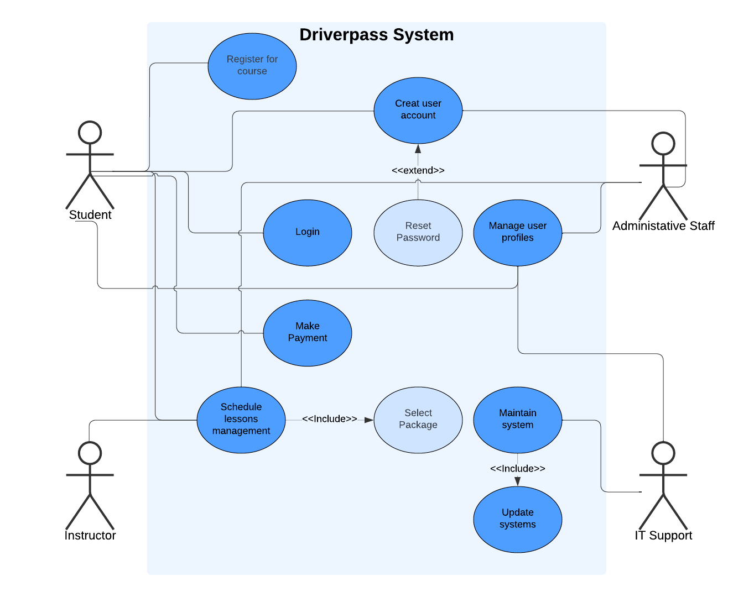

### UML Activity Diagrams

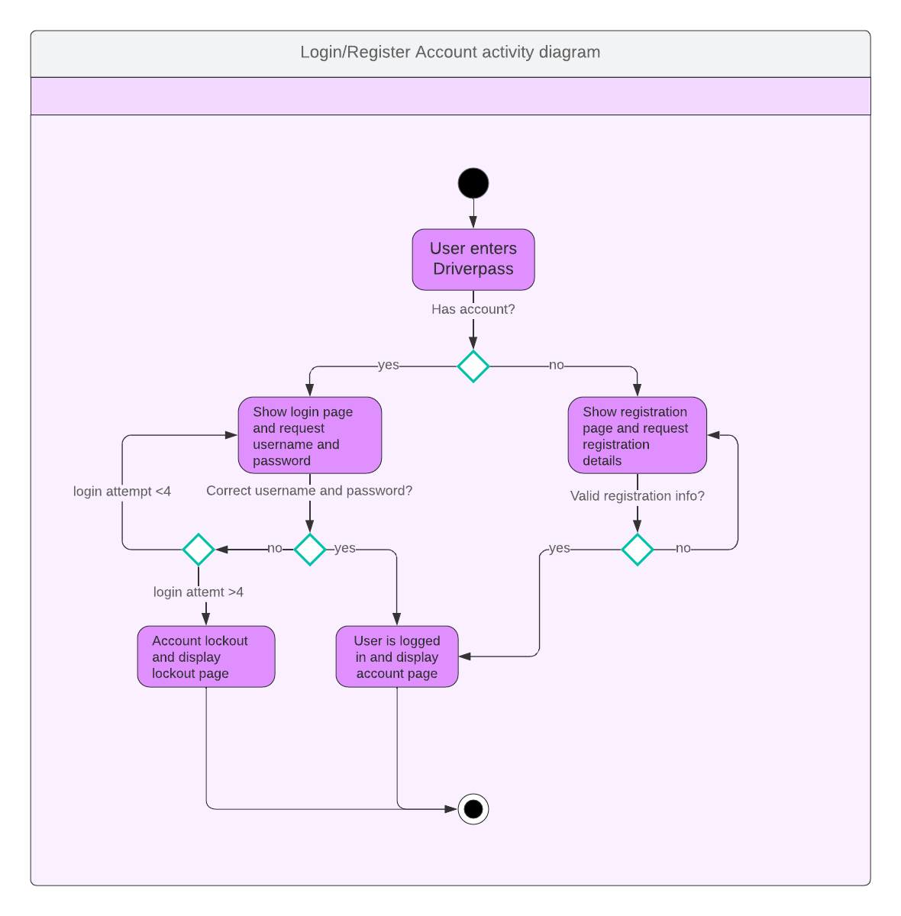

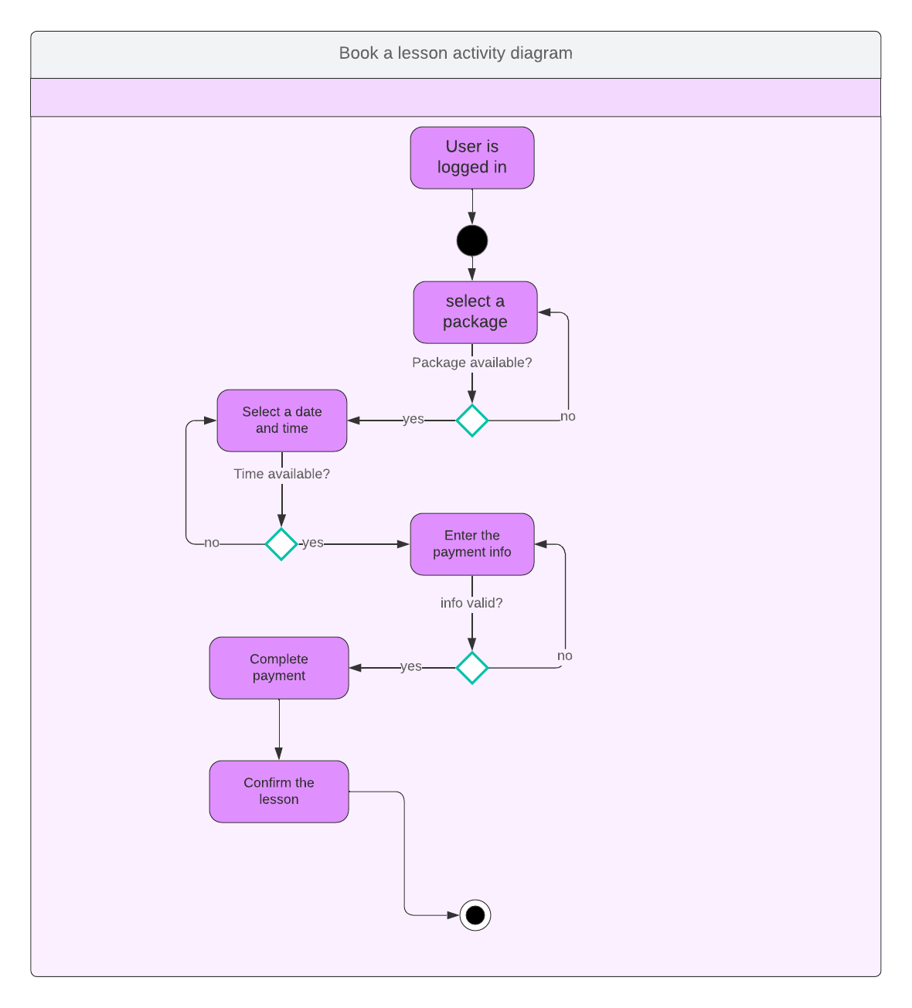

### UML Sequence Diagram

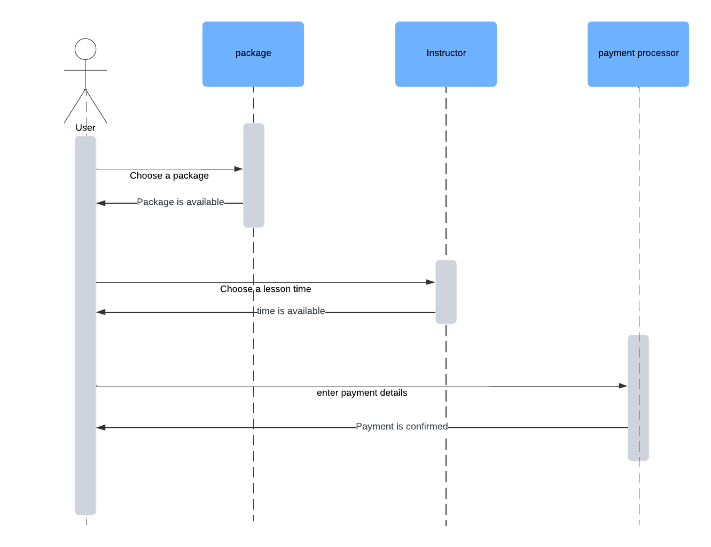

### UML Class Diagram

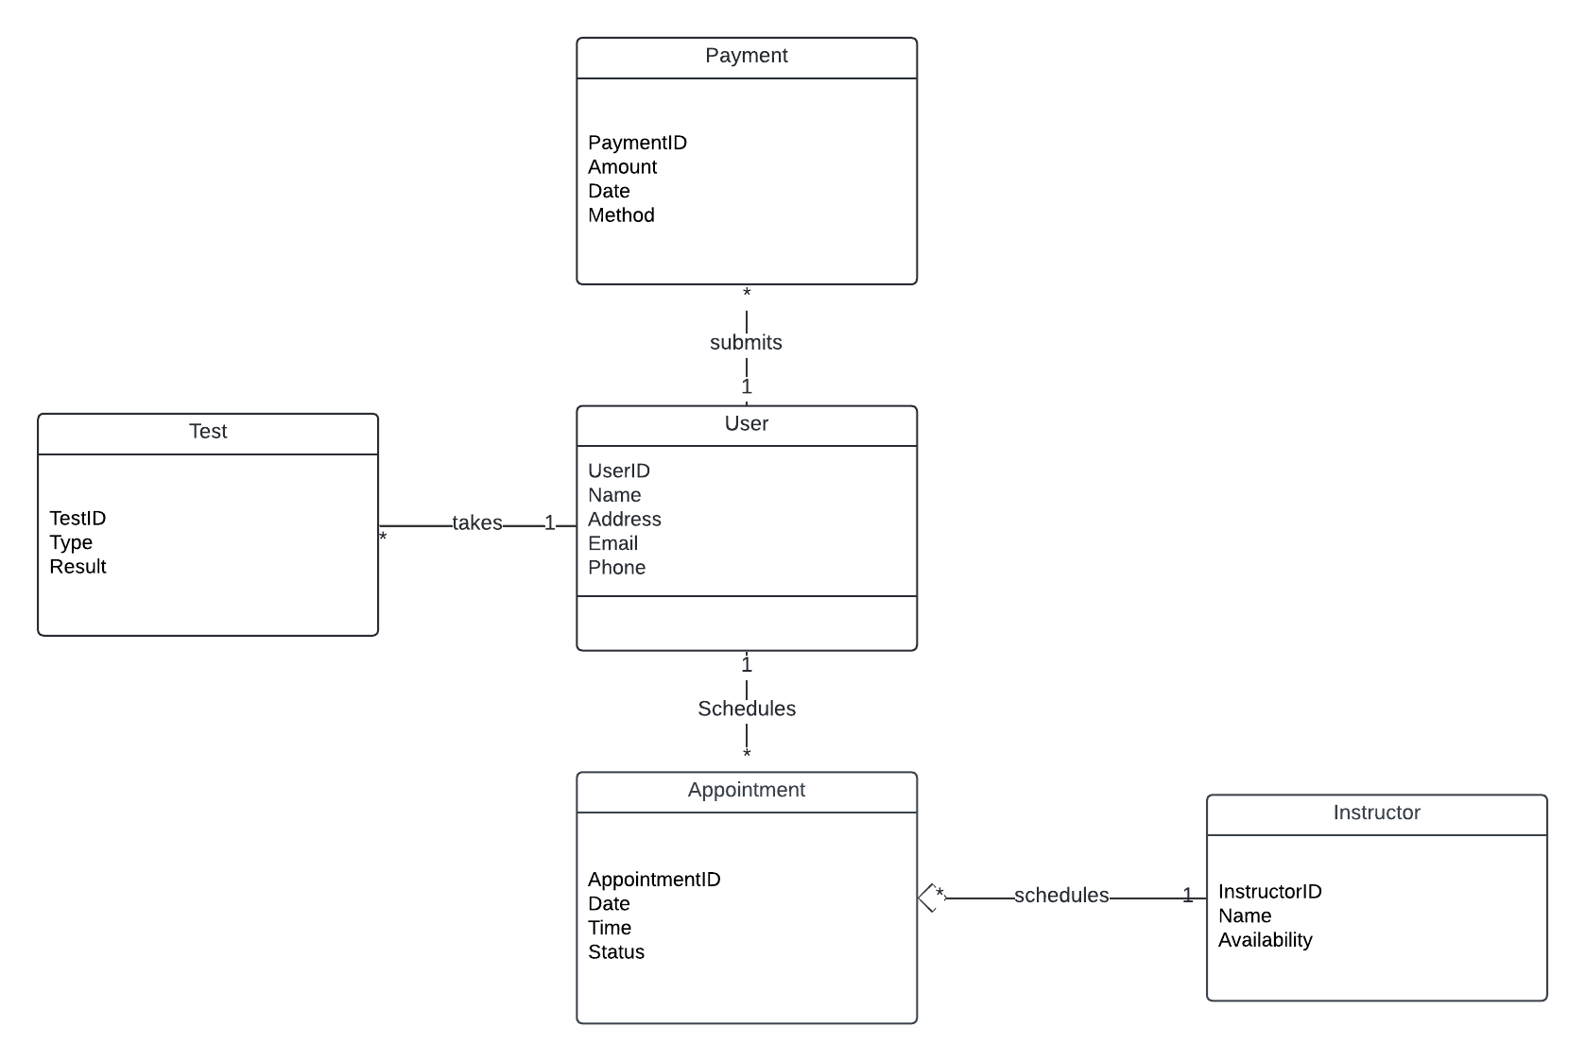

## Technical Requirements

**Hardware Requirements:**

* **Servers:** Servers are needed to host the web and mobile application, It needs to be powerful enough to give fast response times and handle many users at once.
* **User Devices:** The system needs to be accessible on most devices including smartphones, tablets, and computers to make sure it meets the needs of users who might access the system in different devices.

**Software Requirements:**

* **Operating Systems:** The system should be compatible with all major operating systems including Windows, macOS, Linux for desktop users, and iOS and Android for mobile users.
* **Web Browsers:** Support for all major web browsers such as Chrome, Firefox, Safari, and Edge to make sure all the users can access the web application.

**Tools and Technologies:**

* **Database Management System:** A database management system will be needed for data storage and management. This will help manage all of the data in the scheduling and booking system.
* **Development Frameworks and Languages:** The system will be maintainable and scalable by using modern, scalable frameworks and languages like React for frontend development and Node.js for backend services.

**Infrastructure Requirements:**

* **Cloud Services:** It will use cloud infrastructure for hosting the application and data. Services like AWS or Azure could be used to manage and store the large amount of data safely.
* **Networking:** Firewalls, load balancers, and DNS settings need to be included to make sure everything is secure and data can pass between the users devices and the servers.

**Maintenance and Support:**

* **Software Updates:** Regular updating the software in the system to help with any security vulnerabilities and to add or update features.

Reference:

Bohl, F. (2021, December 7). How to present design work to non-designers - UX Collective. *Medium*. <https://uxdesign.cc/how-to-present-design-work-to-non-designers-d0cb60ebe21>

Dennis, A., Wixom, B. H., & Tegarden, D. (n.d.). *O’Reilly Media - Technology and Business training*. O’Reilly Online Learning. https://learning.oreilly.com/library/view/systems-analysis-and/9781118037423/09_chapter004.html#ch004

*Hit the Mark: Make Complex Ideas Understandable*. (2024, August 13). Stanford Graduate School of Business. https://www.gsb.stanford.edu/insights/hit-mark-make-complex-ideas-understandable

*UML Sequence Diagram Tutorial*. (n.d.). Lucidchart. https://www.lucidchart.com/pages/uml-sequence-diagram

*UML Activity Diagram Tutorial*. (n.d.). Lucidchart. https://www.lucidchart.com/pages/uml-activity-diagram